**7 Animating The Spheres**

1. Create **Mountain** Node [attribpaint1, scatter1 and relax1], set Group = @density>0.0;
2. Select mountain1/offset, shift + Click,alt + Click,set 0 at frame1, set 2 at end frame, Play Animation, slow, delete Mountain node;
3. Create **Normal** Node [grid1, attribpaint1], set Add normals to Points, Create **Attribute VOP** Node after attribpaint1, enter, add Add node, P + N = P;
4. Create **Unified Noise** Node, Set Offset.y = $FF*0.2, Fractal Type = Terrain, Max Octaves = 2;

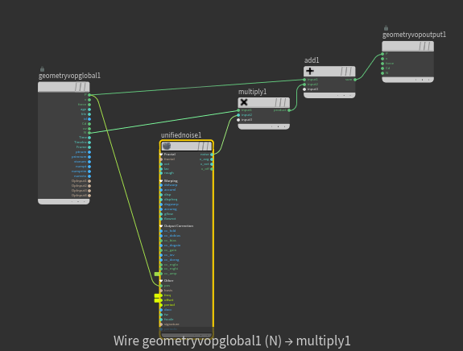

1. Promote Parameter cc_amp, freq, offset

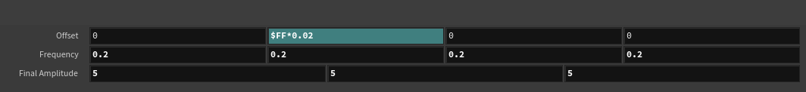

1. Set attribvop [relax1, attribrandomize2]